

**ONLINE COA-ADMIN**

**User Manual**

**V 1.0**

The information in this document may not be disclosed outside of intended recipients and may not be duplicated, used or disclosed in whole or in part for any purpose other than evaluation. RapidQube retains ownership of this document.

**Legal verbiage**

Copyright© 2024, RapidQube Digital Solutions Pvt. Ltd. All rights reserved. RapidQube is a Registered Trademark. All other company and product names may be Trademarks, Registered Trademarks or Service Marks of the companies with which they are associated. RapidQube reserves the right at any time and without notice to change these materials or any of the functions, features or specifications of any of the software described herein. RapidQube shall have no warranty obligation with respect to these materials or the software described herein, except as approved in RapidQube's License Agreement with an authorized licensee.

Table of Content

1.General Information

1.1 System Overview-------------------------------------------------------------------------------------- 4

1.2. System Summary--------------------------------------------------------------------------------------4

1.3 Using the System---------------------------------------------------------------------------------------4

2.Login With Super Admin--------------------------------------------------------------------------------5

3.Register-----------------------------------------------------------------------------------------------------7

3.1. Email Verification--------------------------------------------------------------------------------------7

4.User----------------------------------------------------------------------------------------------------------9

5.Service------------------------------------------------------------------------------------------------------11

5.1.API---------------------------------------------------------------------------------------------------------11

5.2. Rules------------------------------------------------------------------------------------------------------13

5.3. Register--------------------------------------------------------------------------------------------------19

5.4. Documents---------------------------------------------------------------------------------------------23

6.FAQ----------------------------------------------------------------------------------------------------------25

7.Comapny---------------------------------------------------------------------------------------------------26

8.Feedback---------------------------------------------------------------------------------------------------28

9.Logs----------------------------------------------------------------------------------------------------------31

10.Installation and setup of Online COA--------------------------------------------------------------33

**Document Administration**

* Revision History

|  |  |  |  |  |
| --- | --- | --- | --- | --- |
| **Version** | **Issue Date** | **Sections Changed** | **Authors** | **Change Summary** |
| 1.0 | 09/07/2024 |  | Mohamed Asif |  |

* **Approvals**

The following persons will review this Statement of Work Document and provide approval from Customer and Service Provider:

| **Name** | **Title/Role** | **Signature** | **Date** |
| --- | --- | --- | --- |
| Swarnima Gupta | **Technical Architect** |  | 09/07/2024 |

**1.General Information**

* This section explains how the system is organized and the purpose of this manual.

**System Overview**

**1.2 System Summary**

* The System Summary section provides a general overview of the system. The summary section outlines the uses of the system’s hardware and software requirements, system’s configuration, user access levels and system’s behavior in case of any contingencies

**URL FOR LOGIN: https://customer-coa.alba-aws.com.**

* **System Menu**

The Online COA System Menu is presented on the left side of the window as soon as a user logs in. This consists of

* **Dashboard**
* **Register**
* **Users**
* **Services**
* **FAQ**
* **Company**
* **Feedback**
* **Setting**
* **Logs**

**1.3 Using the System**

The “Using the System” section discusses in brief how to start using the ONLINE COA system. The functionality and information inside the web application are elaborated here,

MASTER URL: **https://customer-coa.alba-aws.com**

**2.Login with super admin**

USERNAME: alba.config2alba.com.

PASSWORD: **********

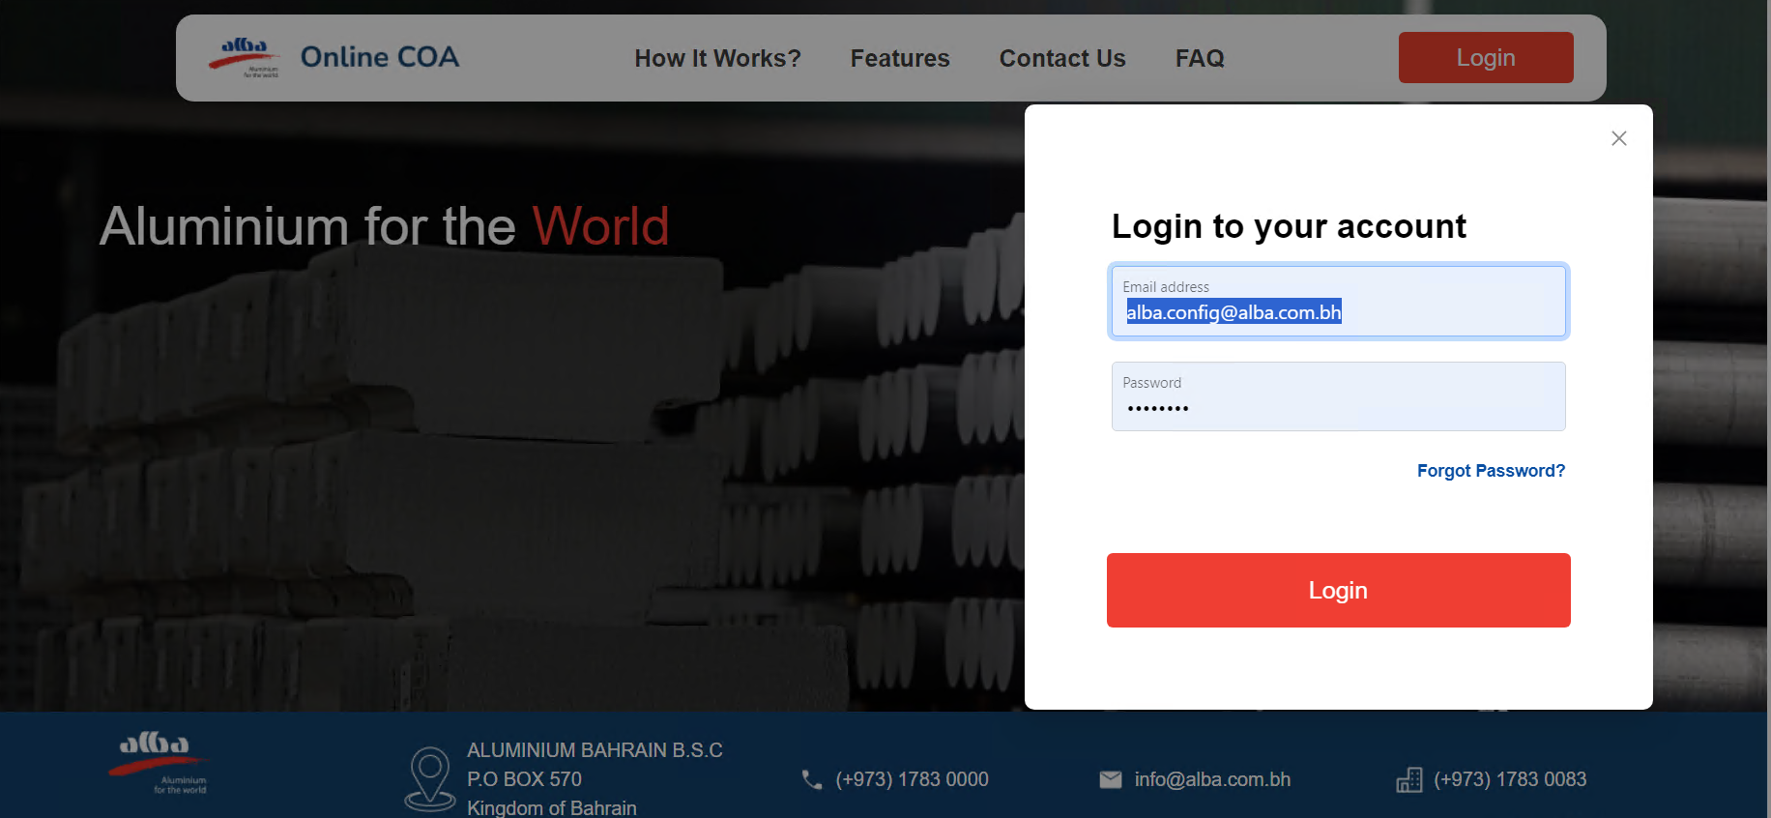

**LOGIN**

* On successful sign in user will be redirected to dashboard. The dashboard will have cards displaying the details of Active Users, Active Company and Display of feedback.

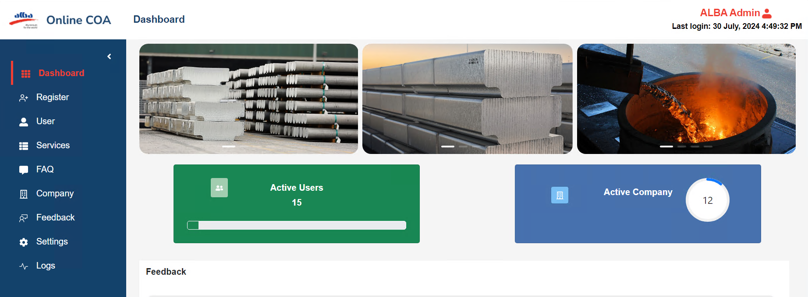

**DASHBOARD**

**3.Register**

On Admin screen, Admin can be able to register (customer/user) by the following steps,

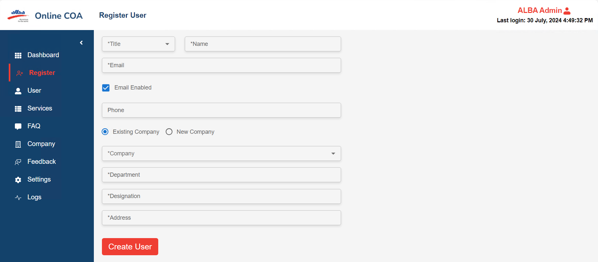

**Register User**

**3.1 E-mail verification:**

**Step:1**

* After clicking create user button, user got notified through email, (Registration link)

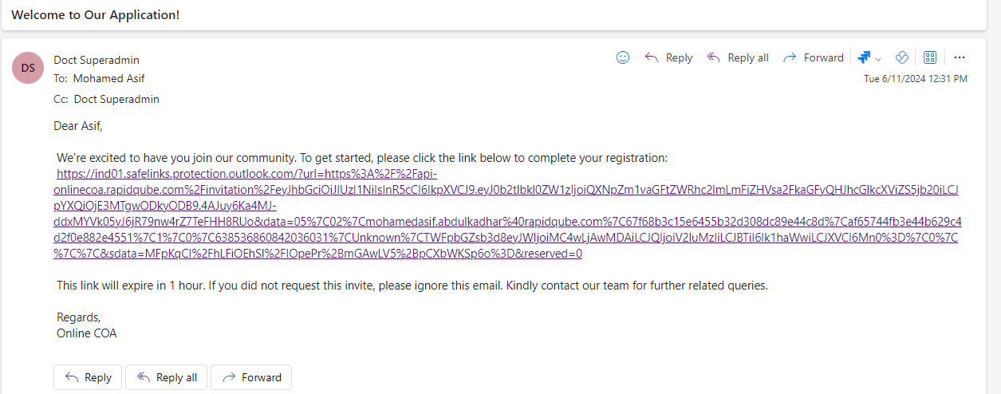

**Mail Verification**

**Step:2**

* Click the registration link and new mail notified with **username** **and temporary password.**

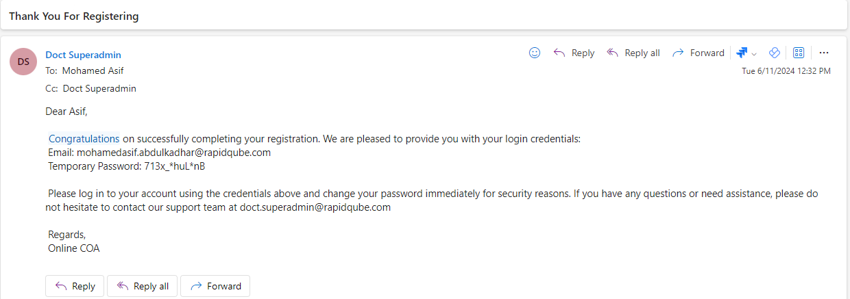

**Registration confirmation mail**

Then, user can be able to login with username and temporary password for customer company

**4.User**

* From user list, it will display the overall company list and It have Id, Name, Email, Company, Designation, Role, Status, Action and Active and Deactive.
* We can be able to perform modify role (either it is admin or user) and user status updating like (Active/ De-active).

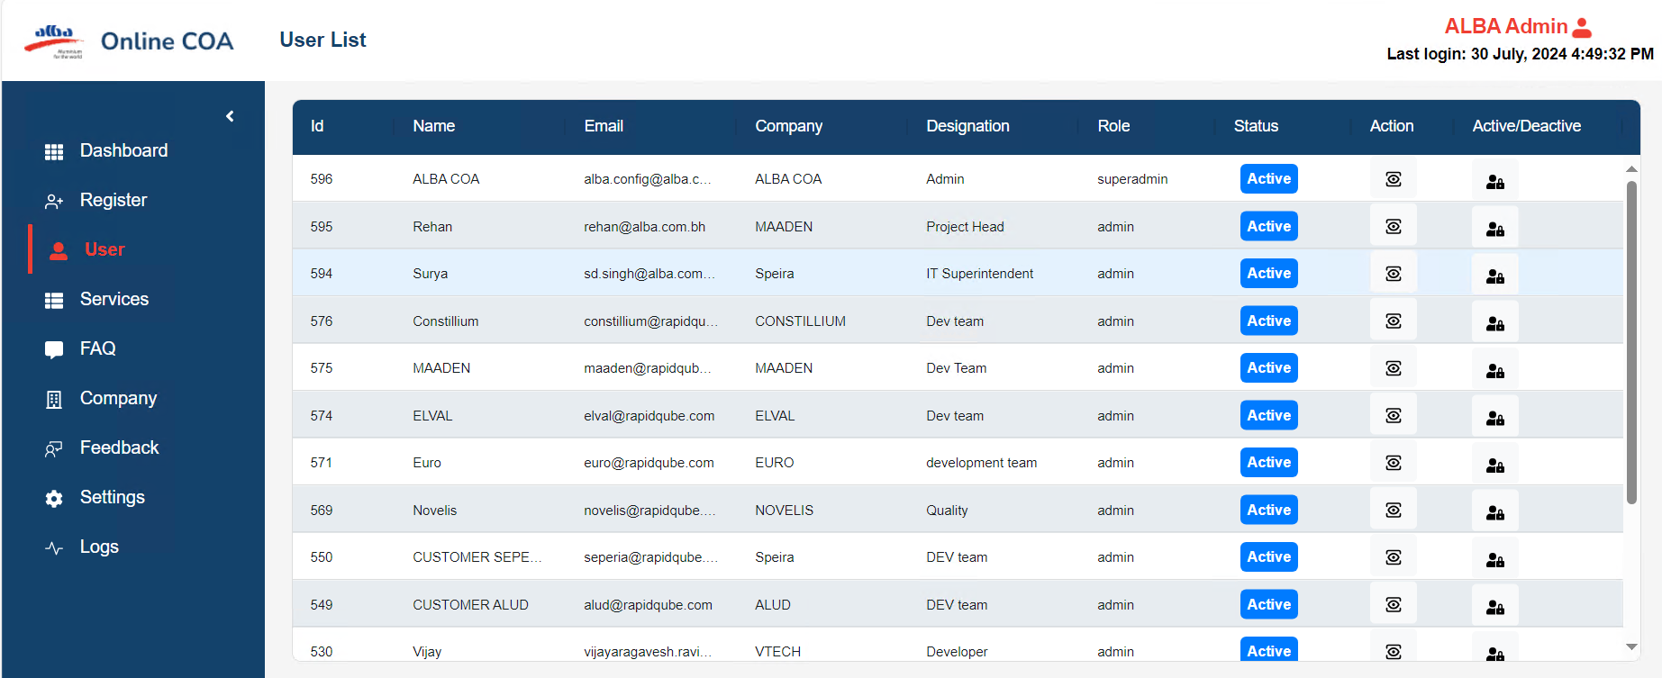

**User List**

* Clicking on Action will give a pop-up modal box they can modify the role with valid reasons submit.

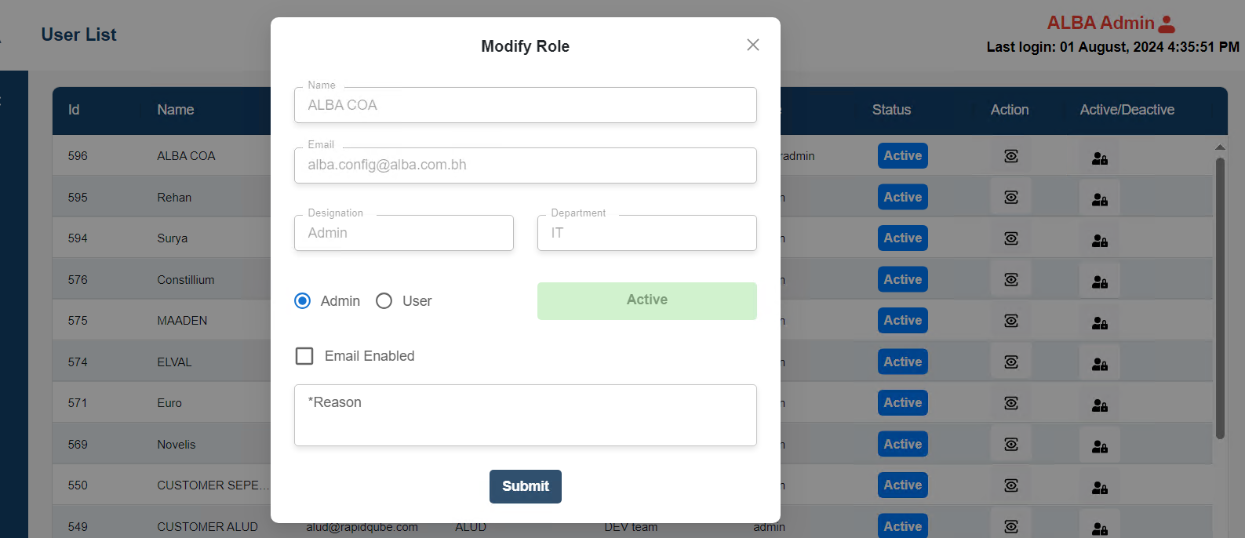

**Modify Role**

* On Click on Active and De-active it will give pop-up modal box in that it has to select the radio button of Active and Inactive and give valid reasons.

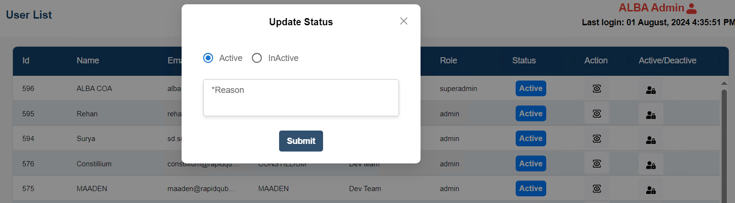

**Update status (Active/Inactive)**

**5.Services**

* It will have APIs, Rules, Register and Document, over service screen we can be able to perform API Request Response, rule creation, rule editing, rule registration from FTPs like custom file and document list.

**5.1 API**

* IT will display the requested API.
* It has Id, Name, Application, email, purpose, API Name, Rule Name, Status, Date and Action, admin can be able to approve the request from customers.

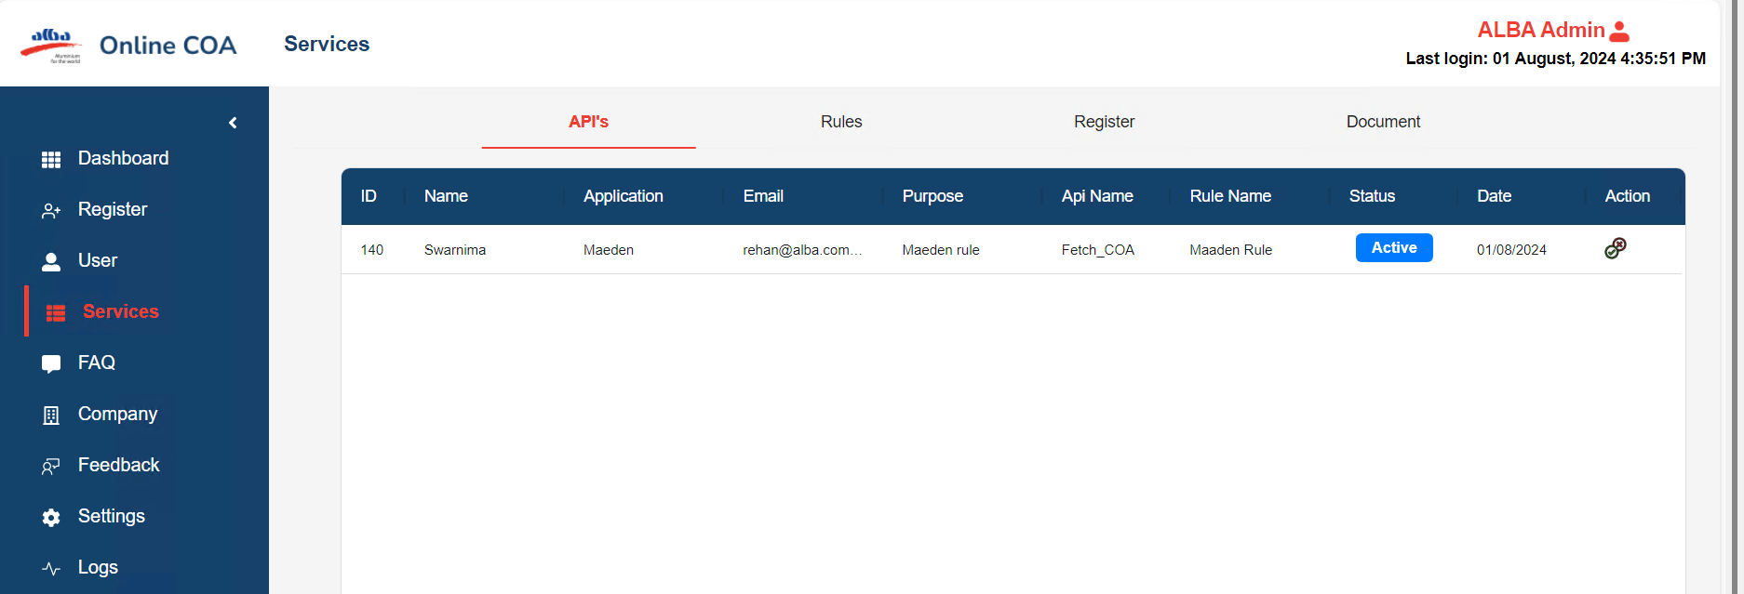

**REQUEST API**

* Click on Action it will give pop-up modal box it has to select the Active and De-active with valid reason API.

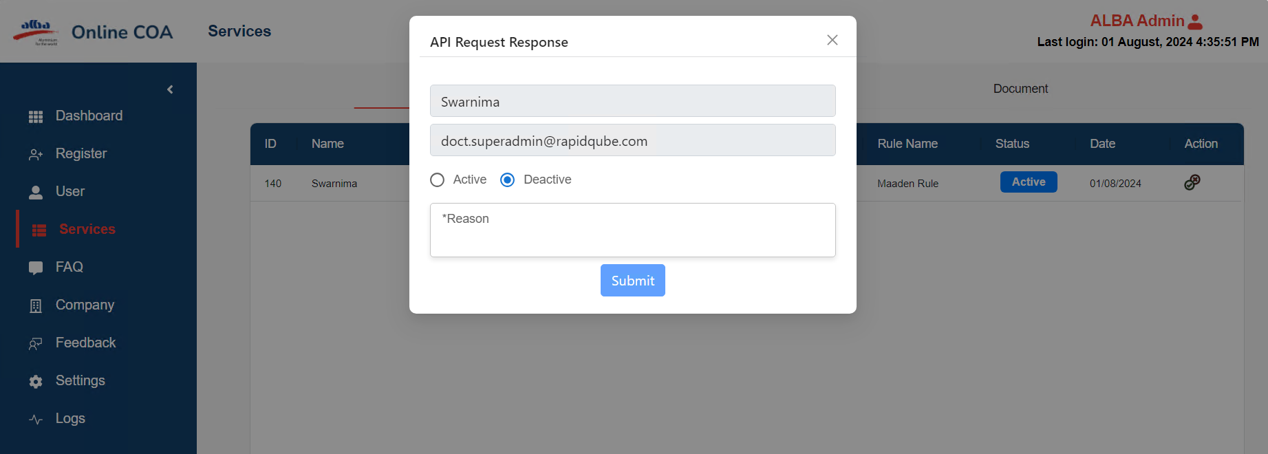

**API Request Response**

**5.2 Rules**

From the rules screen, admin can create a rule for customers based on requirements by using header and details format. While adding new rule add customized column if needed by using add column,

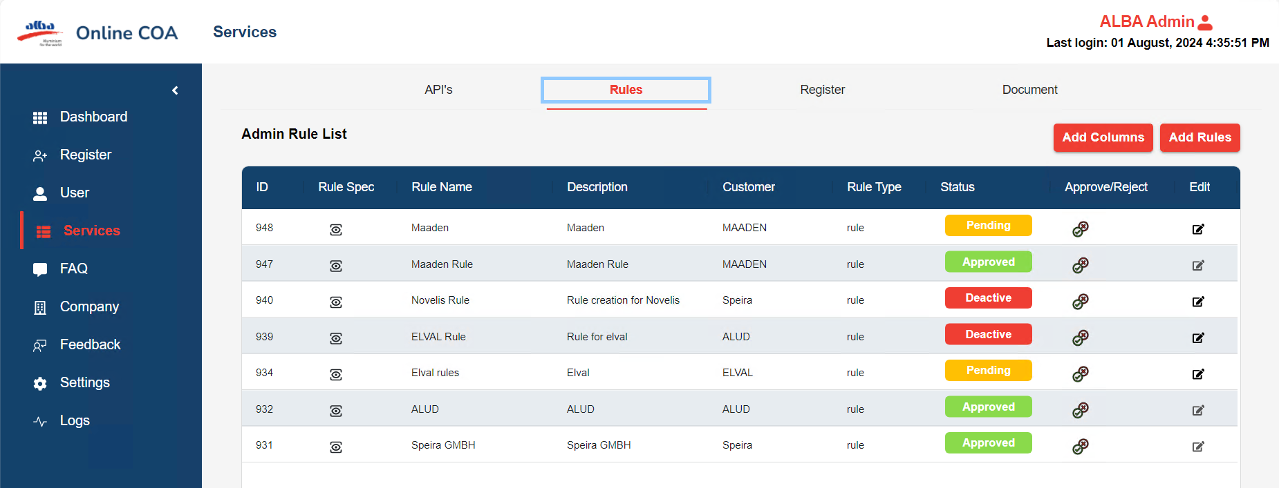

**RULES**

**5.2.1.ADD COLUMN**

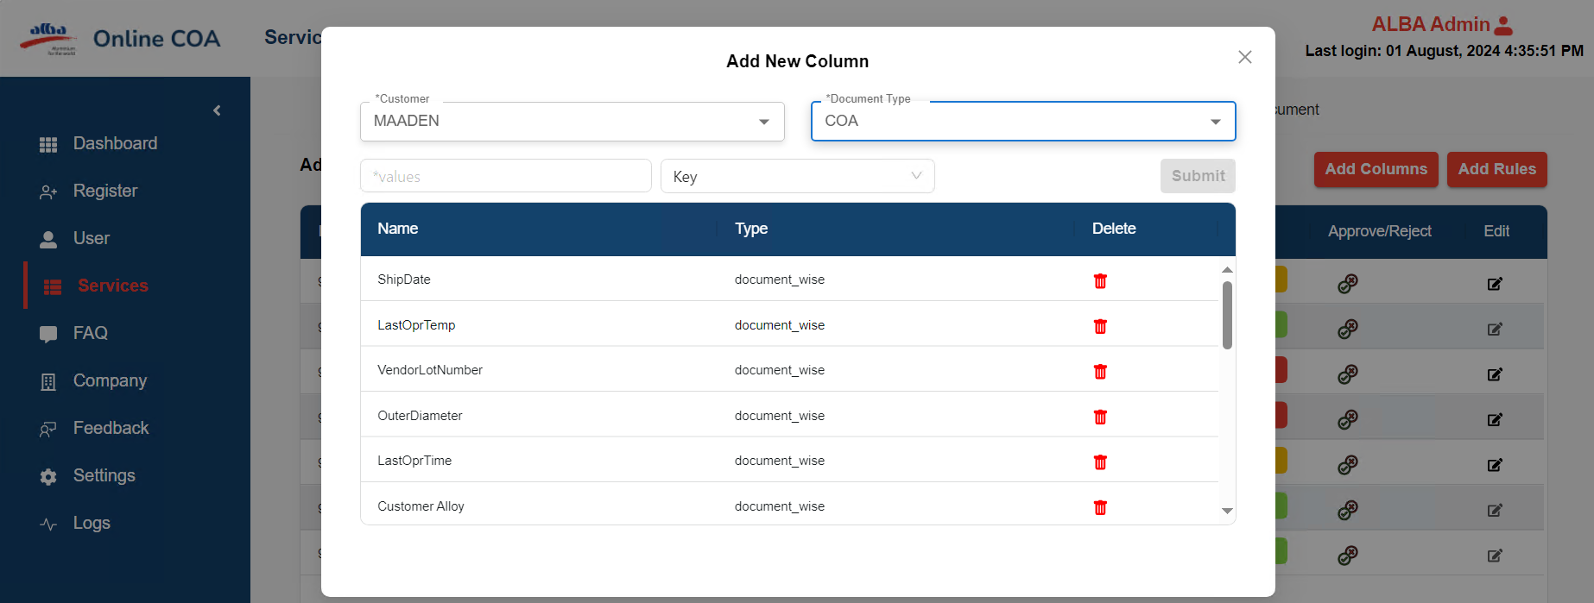

**Add New Column**

* Add column screen is used for adding new column for customer and document type and admin can be able to add or delete key (HEADER or KEY).

**5.2.2.ADD NEW RULES**

* Click on Add Rules it will give pop-up modal box it has Customer, Document type, Rule Name, Rule Description, default as header and details

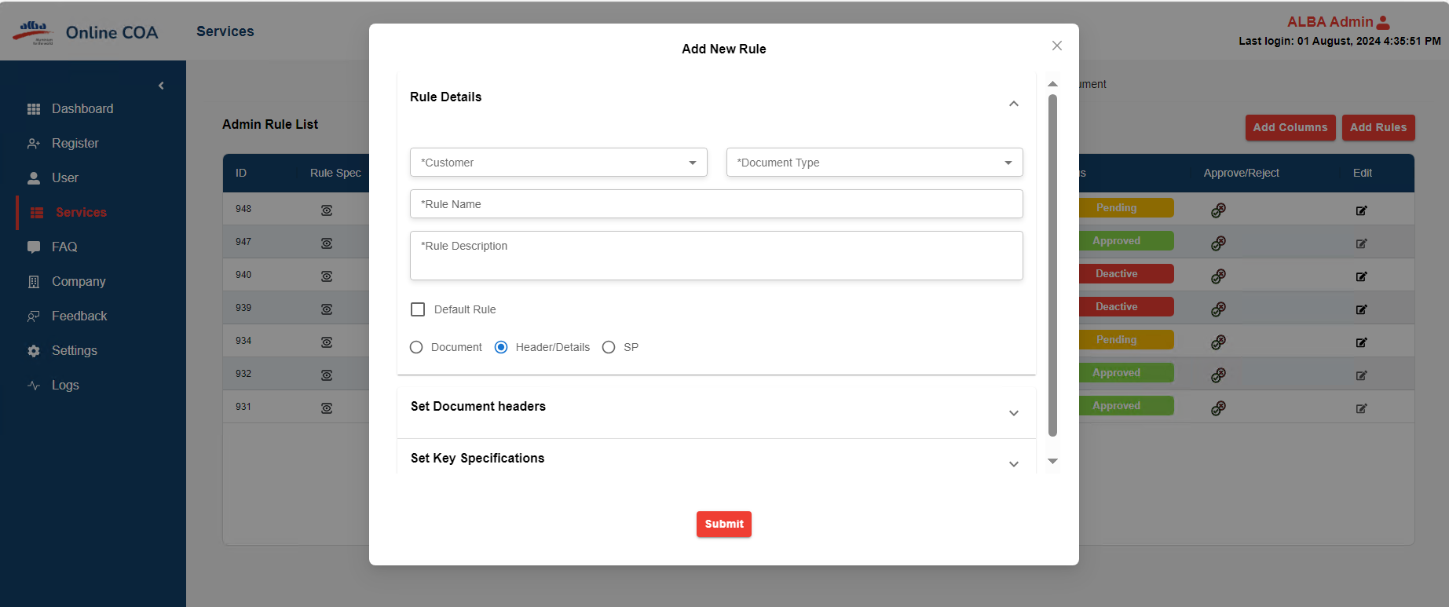

**Add New Rule**

**Add Rule-Document Header**

* It has predefined values for adding document header.

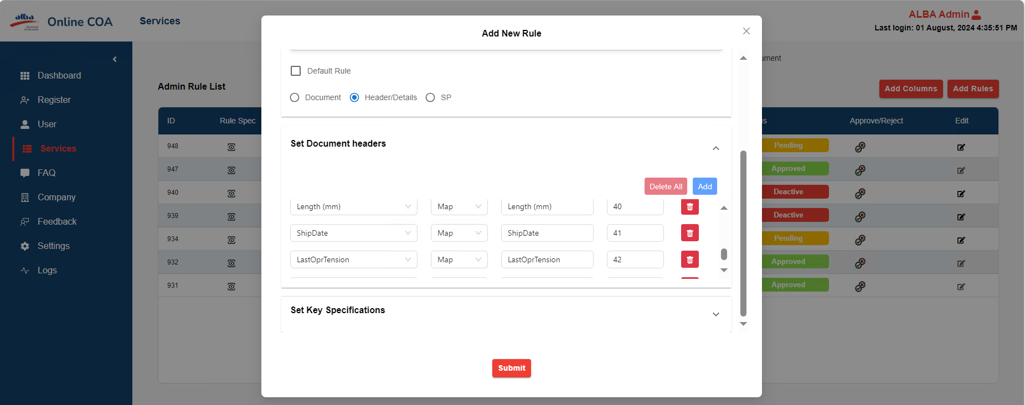

**Predefined document headers**

* On Click on Add of Set Document Headers
* It will give input field of key, parameter, and value

**Add Rule-Document Header:**

* It’s having predefined values for adding Key Specifications,

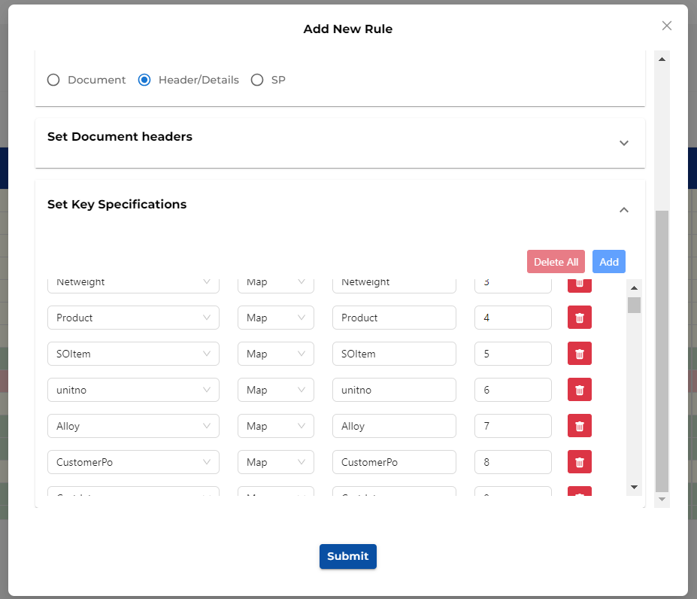

Predefined Key Specification

* Set Key Specification, it will give input field of keys, Parameter and Values
* After click on submit button, it will get display on table
* After that admin accept the request
* On Click on icon it will give pop-up modal box.

* It must select Approve and Reject with valid reasons.

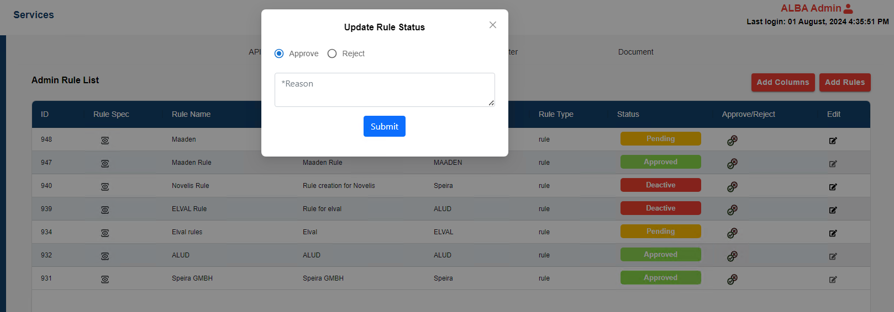

**Update Rule Status**

**EDIT RULE**

* Click edit it will be able to edit the rule must be able to add rule after that click on submit or cancel.

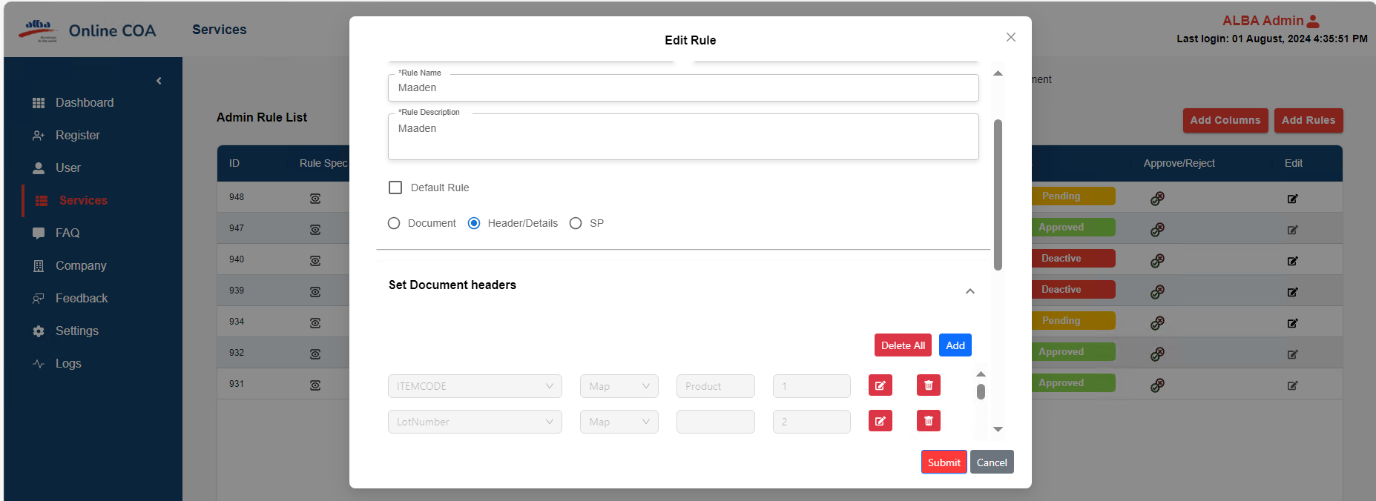

**Edit Rule**

**5.3. Register**

* Users can create their custom file.

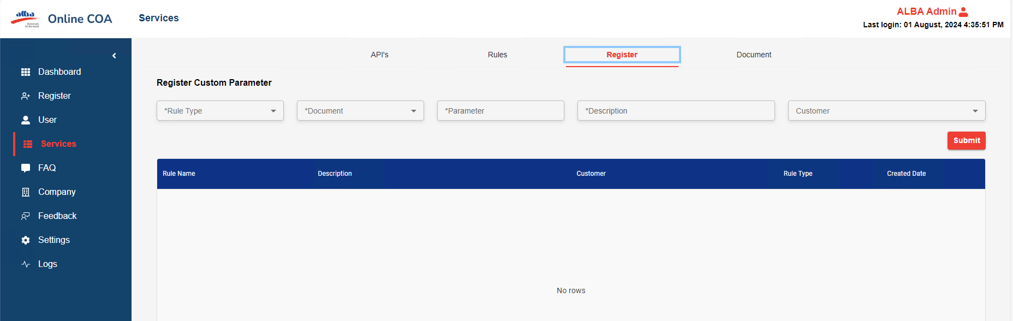

**Register custom parameter**

* On Click on register it will have Rule Type, Document, Parameter, Description and Customer submit button.

**For Parameter**

Users must set up the FTP (File Transfer Protocol) network in your windows,

**Step 1**

* Click on this PC.

**Step 2**

* Click on 3 Dots.

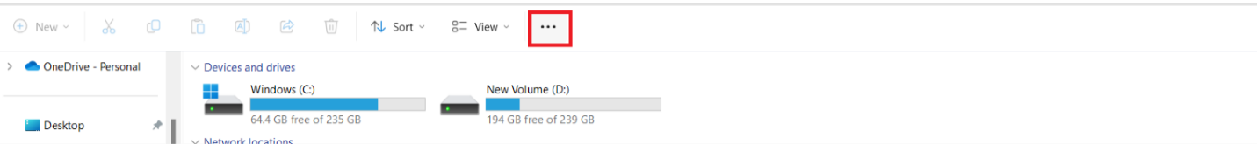

**FTP**

* Click on Add Network location.

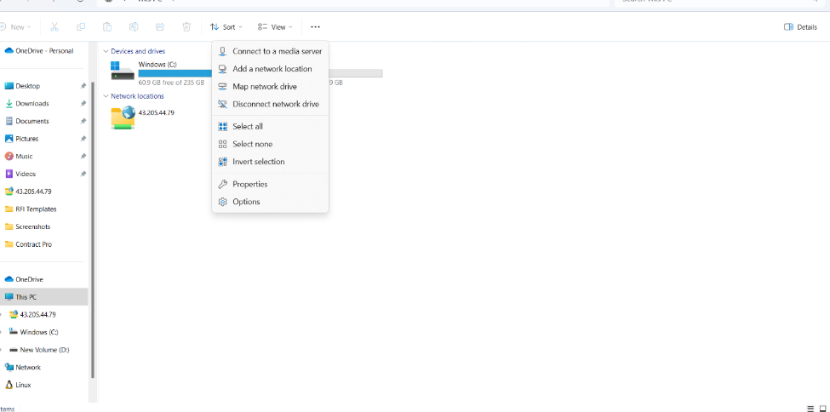

* It will give pop-up modal box.

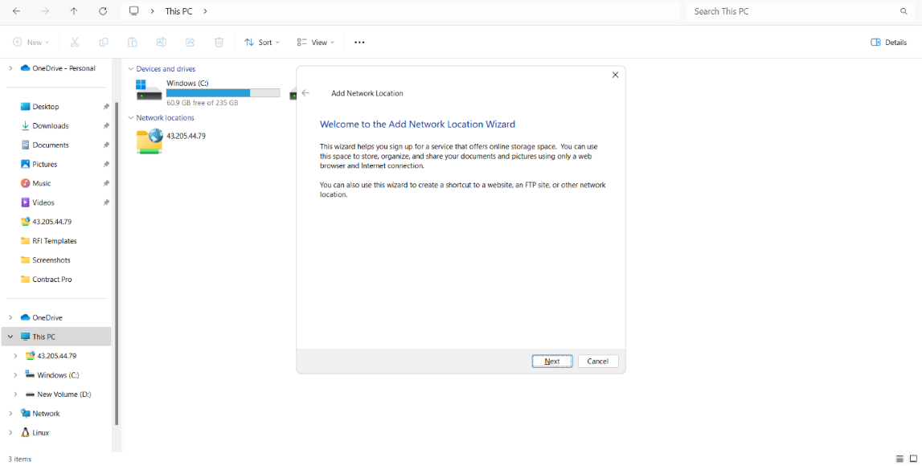

**Click on next**

* It will ask URL to give your FTP network URL.

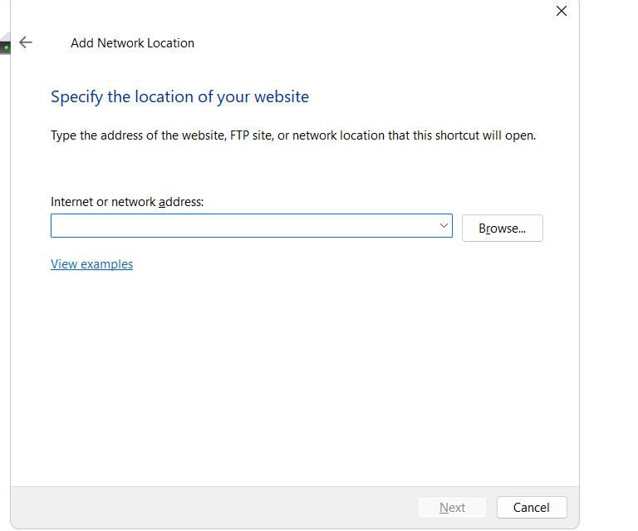

**Click on Next**

* Click on finish.
* After setting up it will show you below this PC.

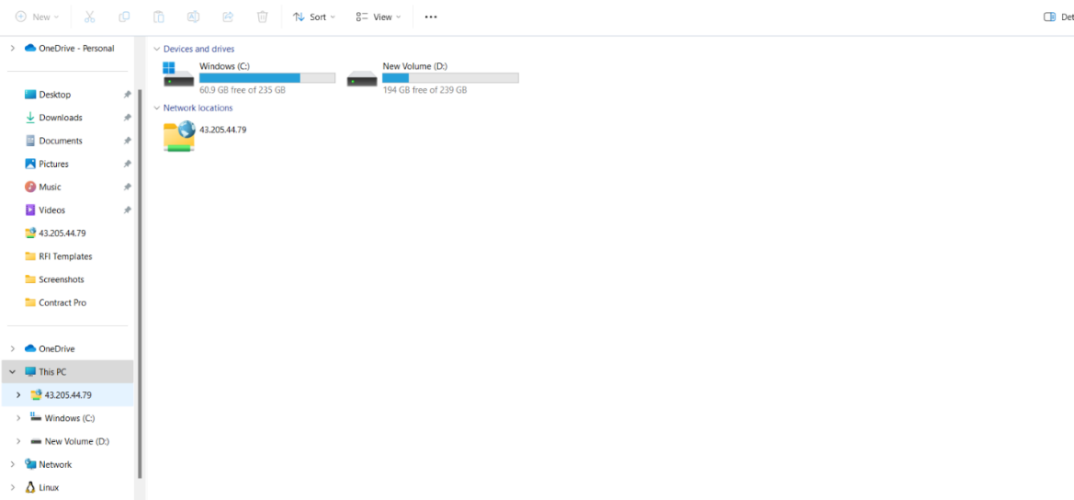

* After you click on your FTP it asks you, your FTP Username and Password.
* Give Rule type, Parameter description you want to give and on Click on customer it will give dropdown And Click on Submit.
* It will display in table for custom file you have to add the rule as above it is said.

**5.4 Documents**

**Document Lists**

* It has Customer, Document Type, parameter, value, from date and to date, Submit button.

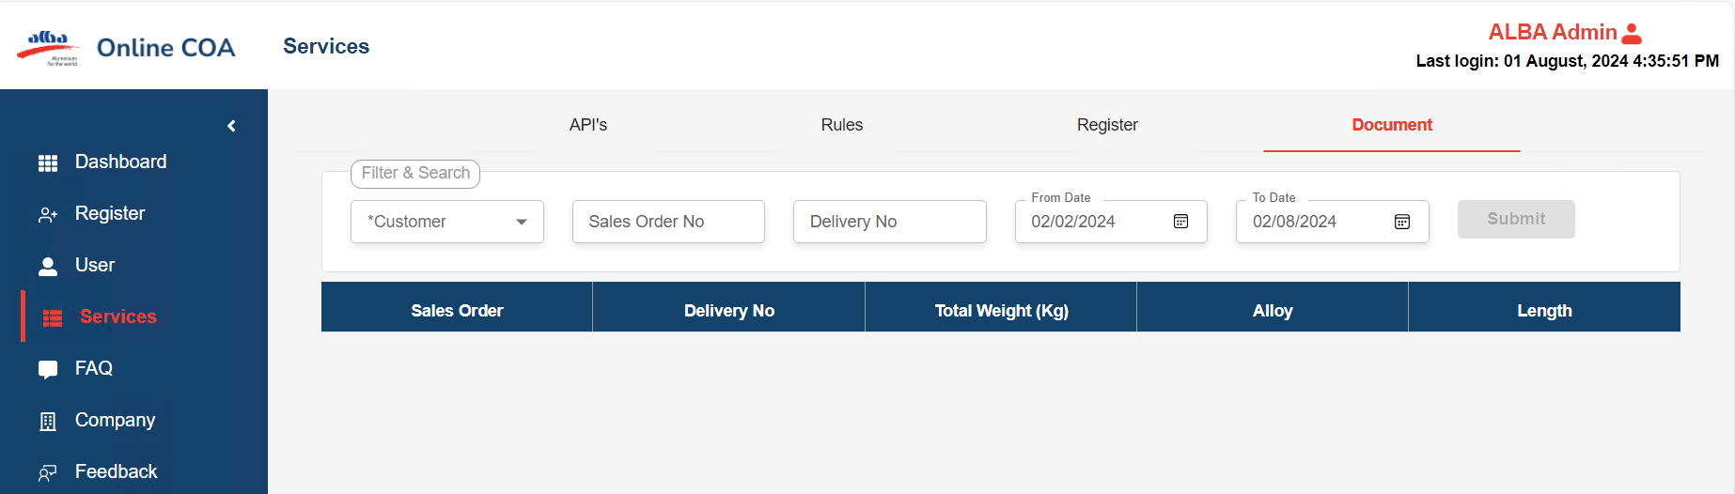

**DOCUMENT LIST**

* In dropdown it will give customer name select one of customer.

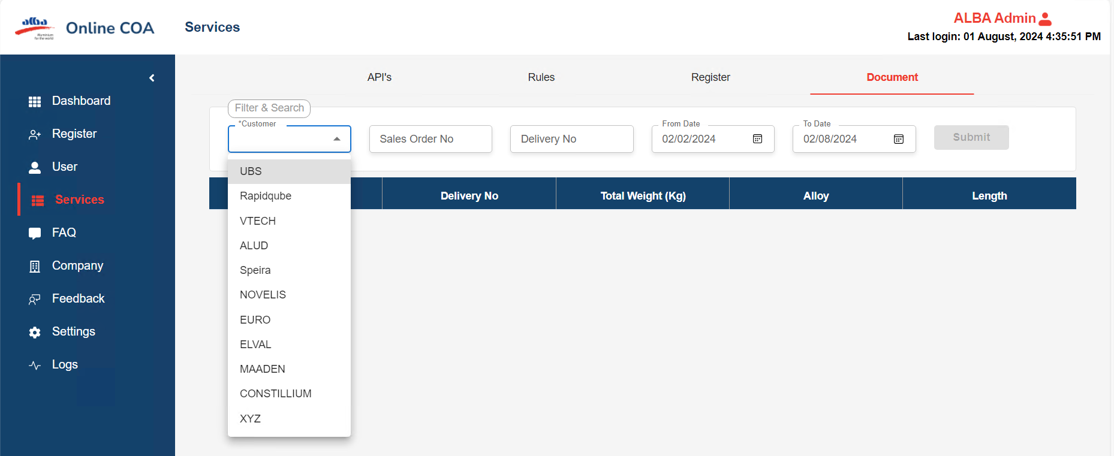

* After clicking on submit it will give a rule box and display the data.

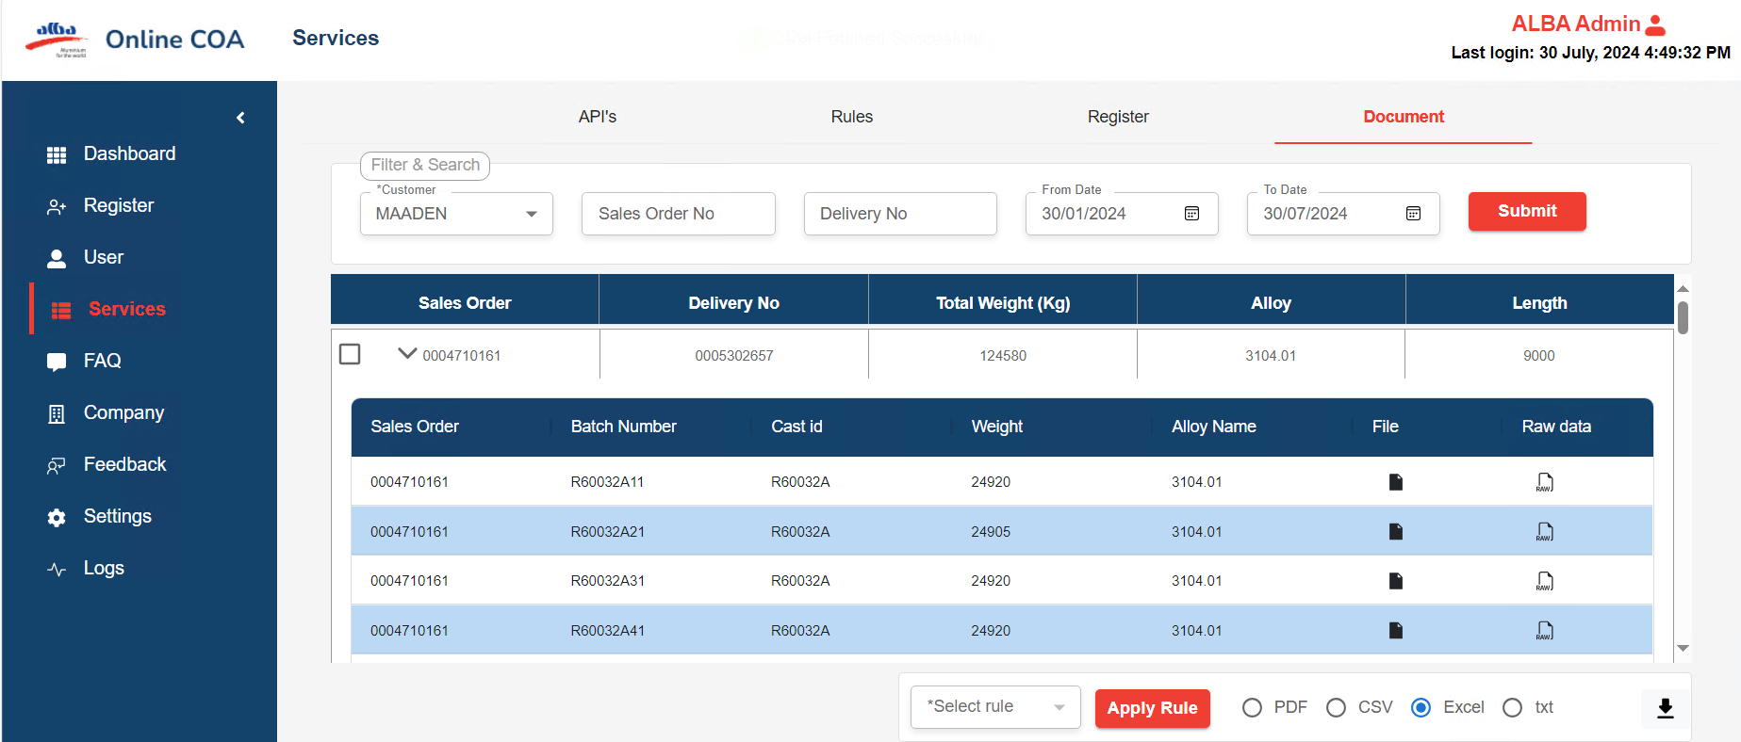

* Select check from table same SO number and from dropdown it will give.

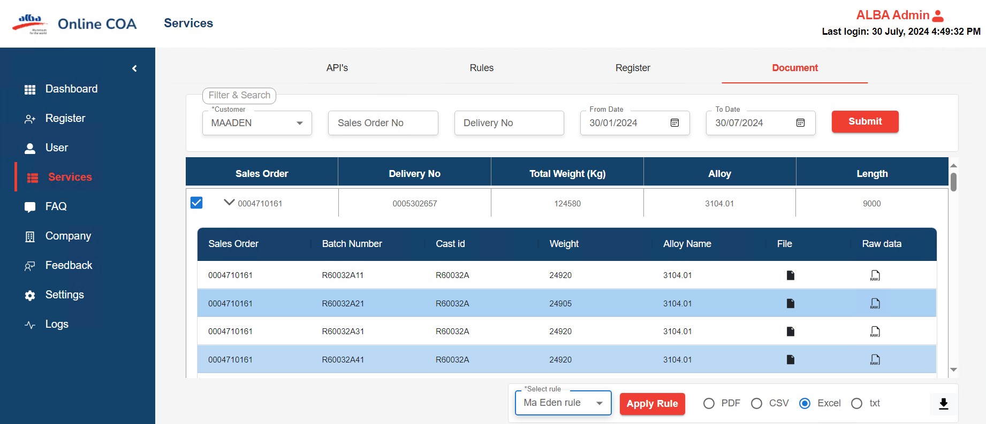

* Click on apply rule it will apply rule to that.
* Click on file it will have table and Json format converted data.

**6. FAQ**

  Admin can Add the FAQ to help users.

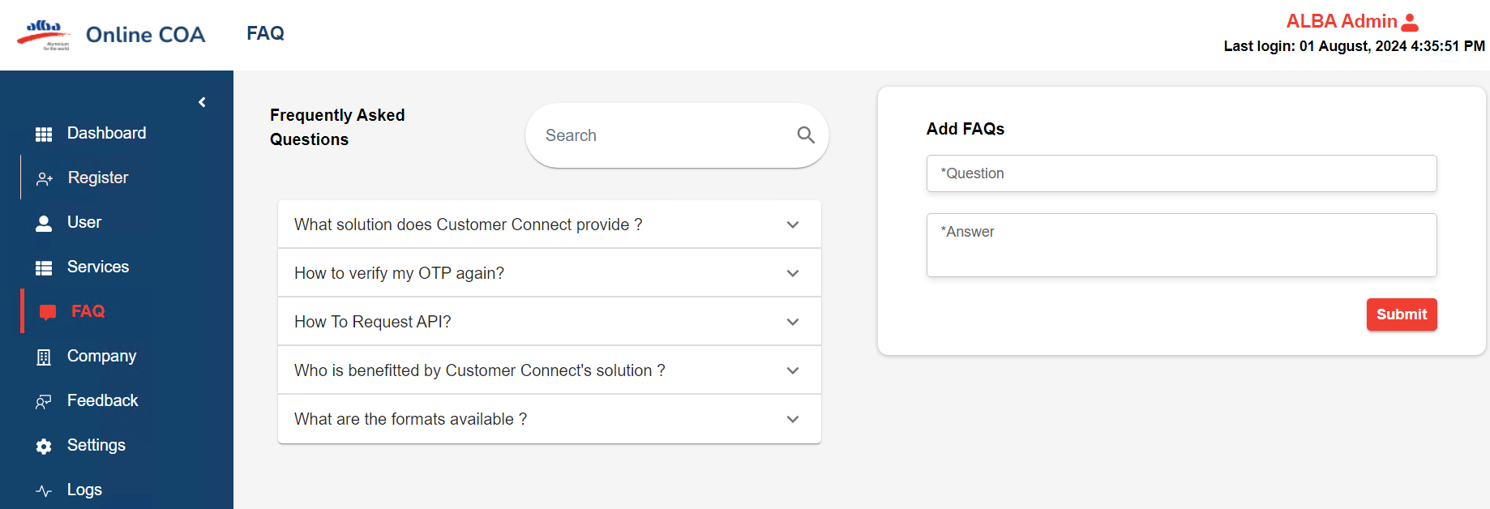

**FAQ**

**7.Company**

* It must select the Active company, Requested Company and Company Mapping and Active Company.
* It will have Id, Company Name, Company Status, Admin Name, Email, Address and Phone.

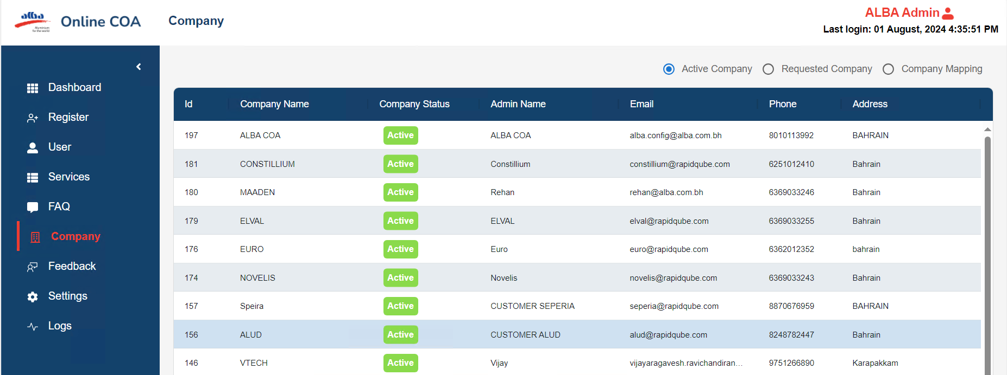

**Active company**

 Initially it is in requested company status while logging into new customer, admin needs to provide approval.

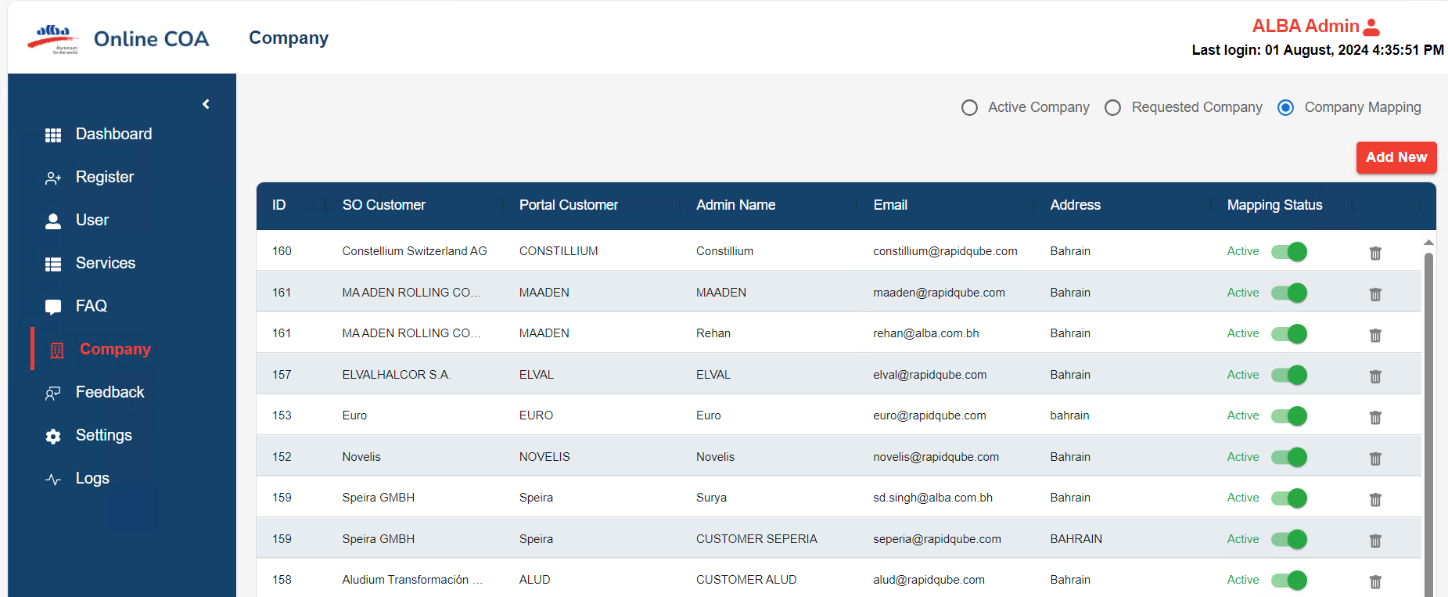

**Company mapping**

* On Click on ADD New it will give the pop-up modal box.
* As GLYCO is SO company.
* The portal company is MD INFRA.
* Select active or inactive and add it will display.

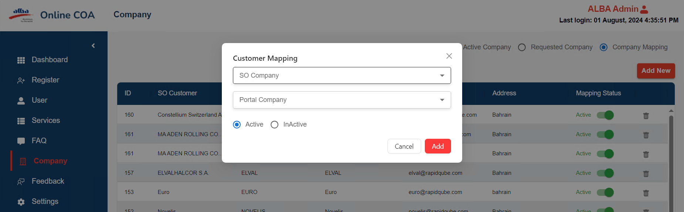

**8.Feedback**

* It will have Customer Feedback and FAQ feedback.
* Select Customer feedback it will display the Id, Name, Email, Date, Response and Rating.

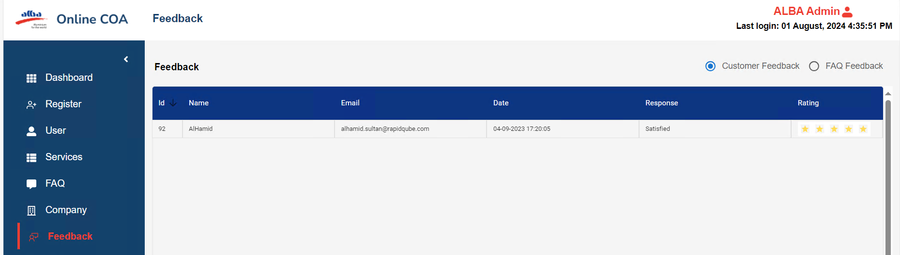

**Feedback**

**Settings**

Click on Setting it will have Profile setting and message preferences.

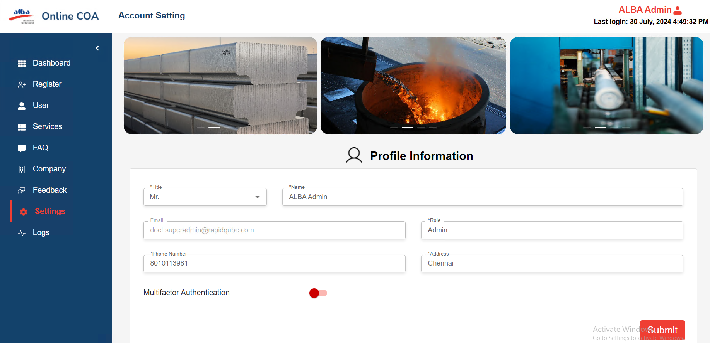

 1) Profile Setting – It will give Data which are given during registration, and it is editable

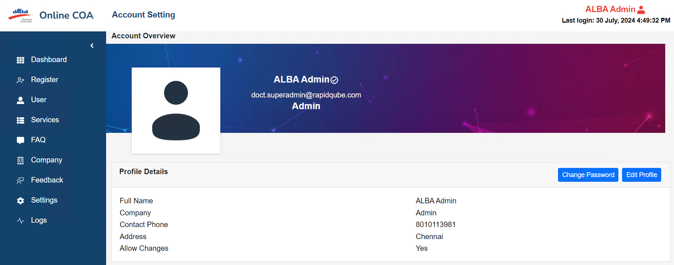

Profile settings

9. **Logs**

It has User logs and API Logs

**1)User Logs** – It will display the Id, name, email, designation, role, Address, status and logs

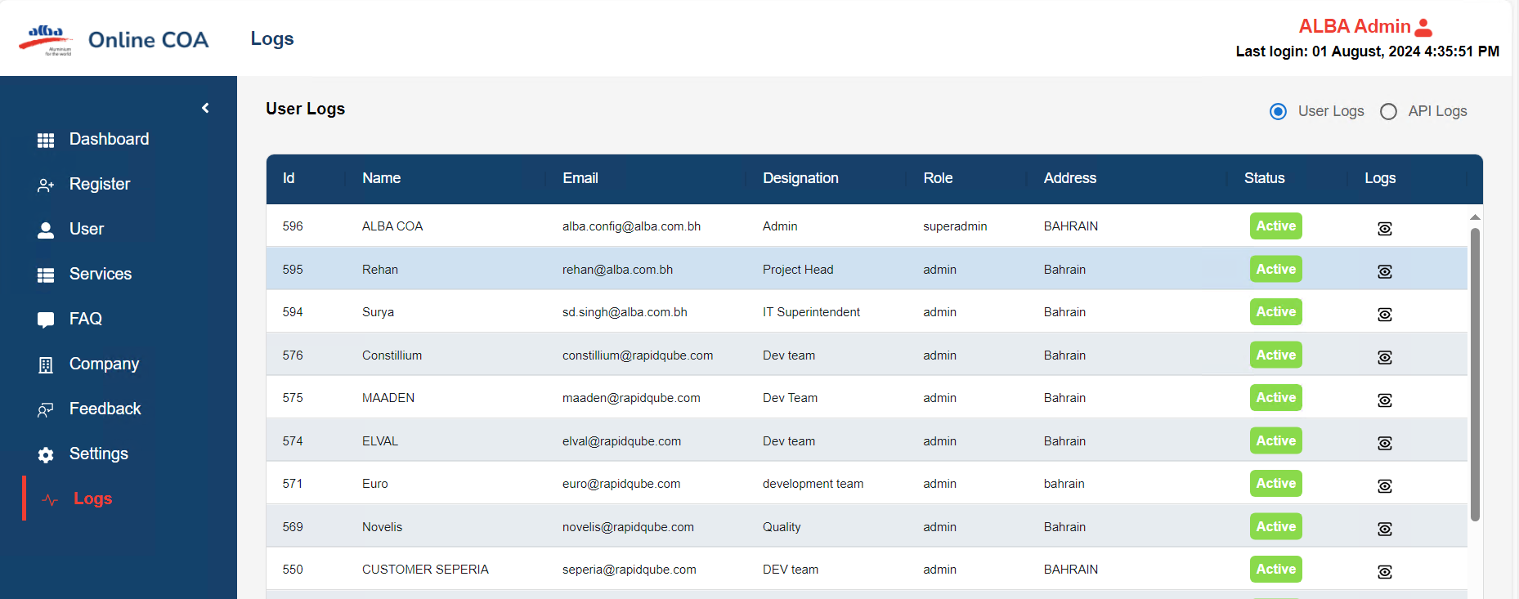

* Click on Logs
* It provides user details.

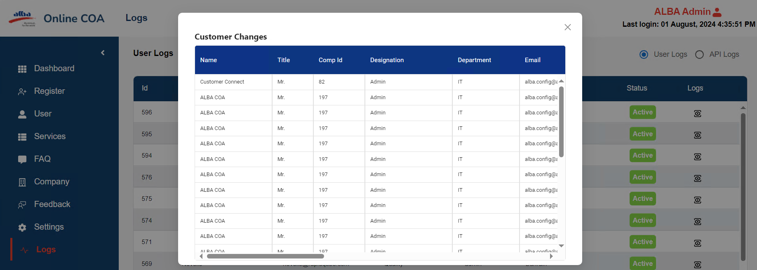

* Api Logs
* It will display the Api id, Api name, App name, Requestor, Email and Logs.

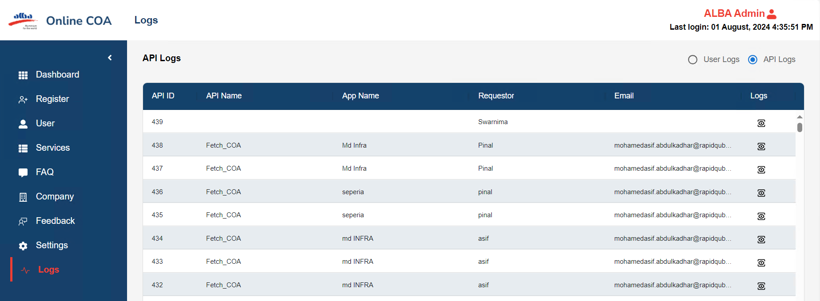

**API Logs**

**10.Setting up for New Customer**

* First admin needs to verify mail on AWS SES server and got approval from AWS

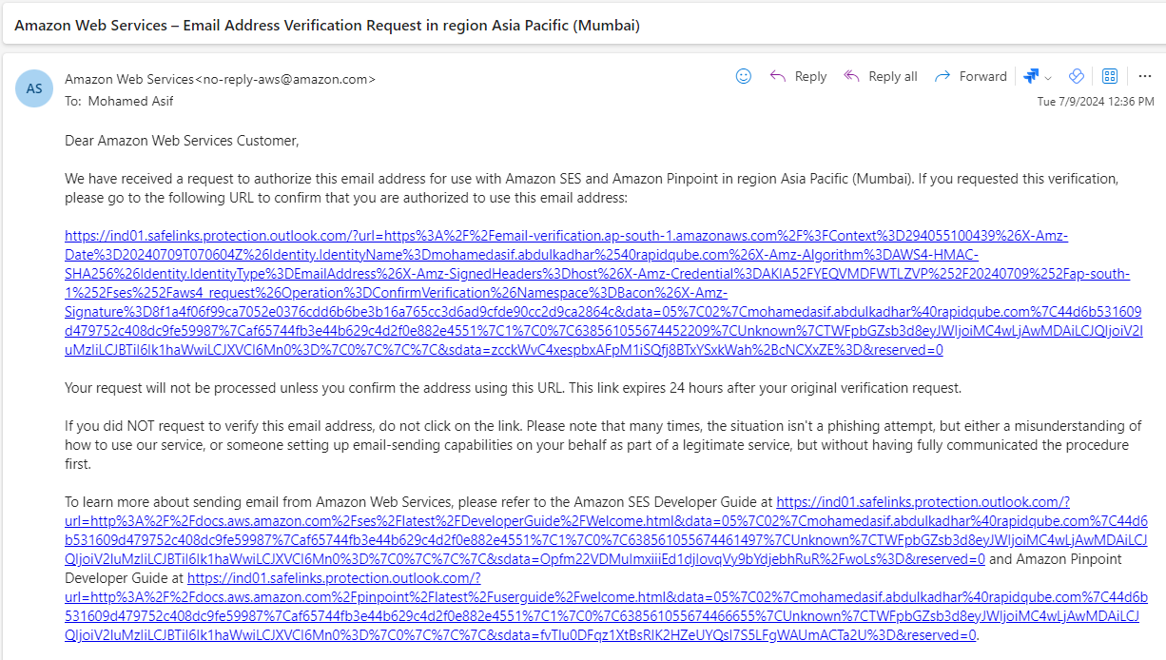

* Step 1:

After requirement from customer, admin need to create an account for user and User will get mail when admin created account in mail it will get URL. After clicking on URL, it will again get mail. **URl:** [**https://customer-coa.alba-aws.comregisteruser**](https://onlinecoa.rapidqube.com/registeruser)**.**

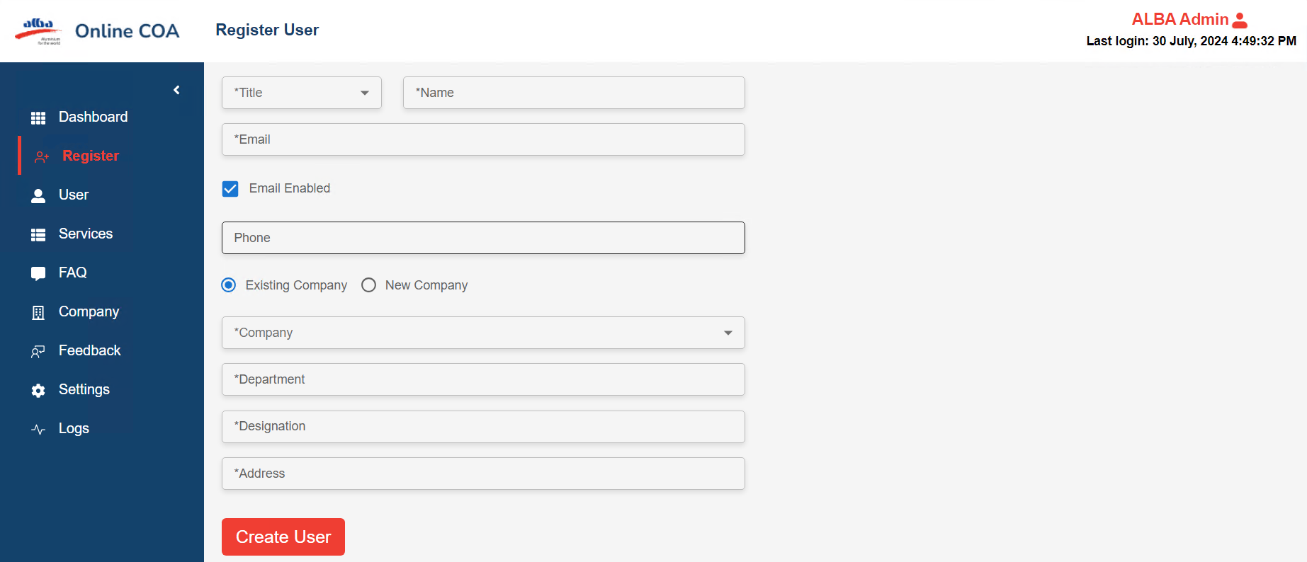

**Register User**

* Step:2

**E-mail verification:** After clicking the create user button, user got notified through email, (Registration link). 

* Step:3

Click the registration link and new mail notified with **username** **and temporary password.**



Registration confirmation mail

Then, the user able to login with username and temporary password for customer company.

* Step:4

Registration confirmation mail URL redirects to the

Master URL ([**https://customer-coa.alba-aws.com**](https://onlinecoa.rapidqube.com/)**)** User can be able to login with username and password which is provided from confirmation mail.

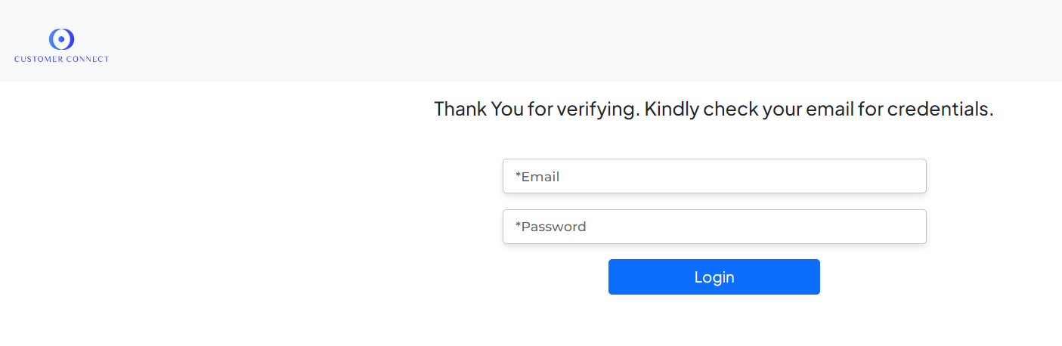

* Step:5

After customer login, that company should show in user list screen, company screen as active status. **URL: https://customer-coa.alba-aws.comcustomerlist**

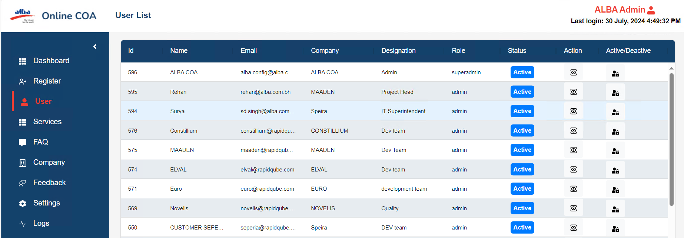

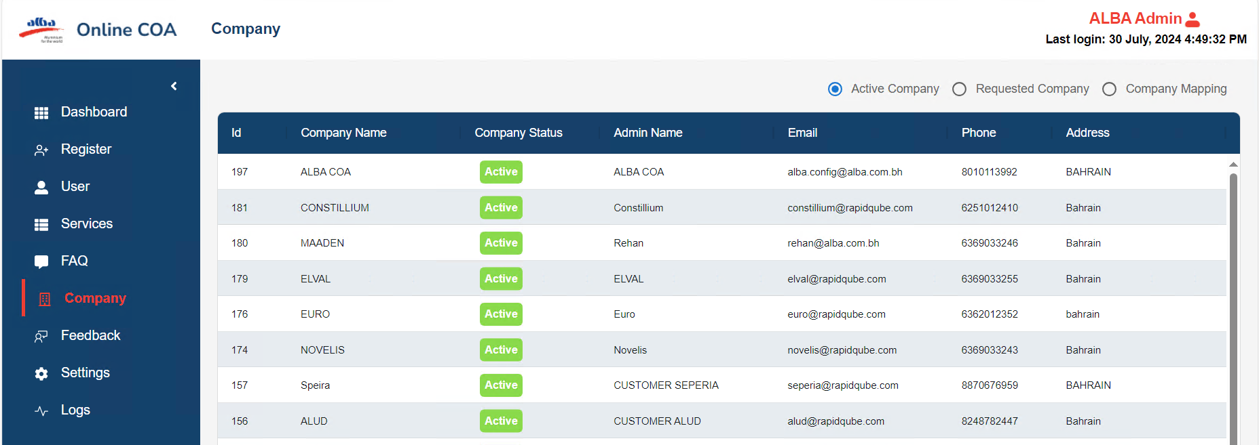

**Setting up for adding new format for Customer (rule creation)**

* Step :6

Click on Services, it will have Navigation bar it has APIs, Rules, Register and Document

**URL:** [**https://customer-coa.alba-aws.comactivecompany**](https://onlinecoa.rapidqube.com/activecompany)

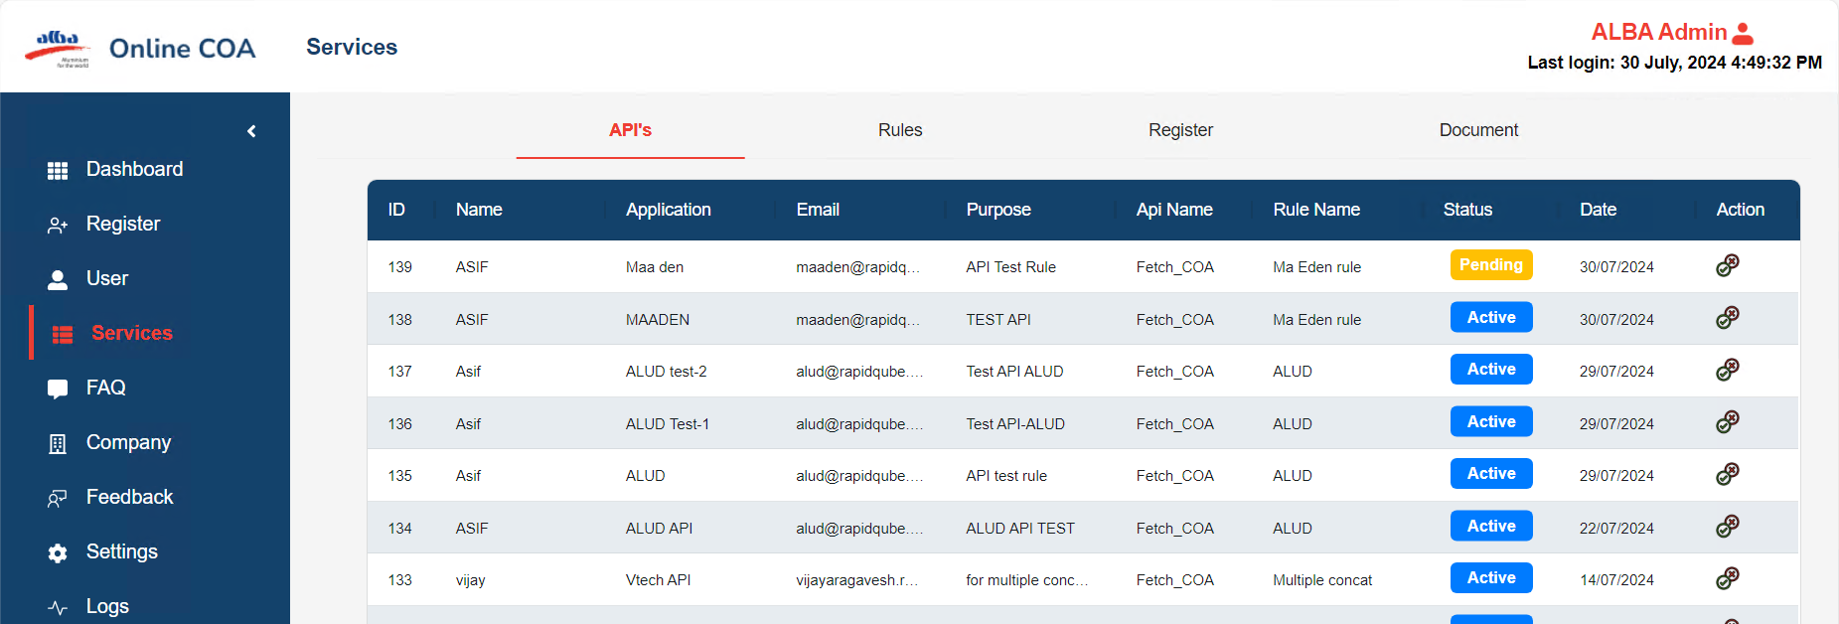

* Step:7

Click on the rules screen and select add rules, Click on Rules it will add column and add rules. Click on Add rules it will open pop-up model box. It will fill in the required details, create a rule as Document, Header Details and SP. It is in the desired format**.URL(**[**https://customer-coa.alba-aws.comservice**](https://onlinecoa.rapidqube.com/service)**)**

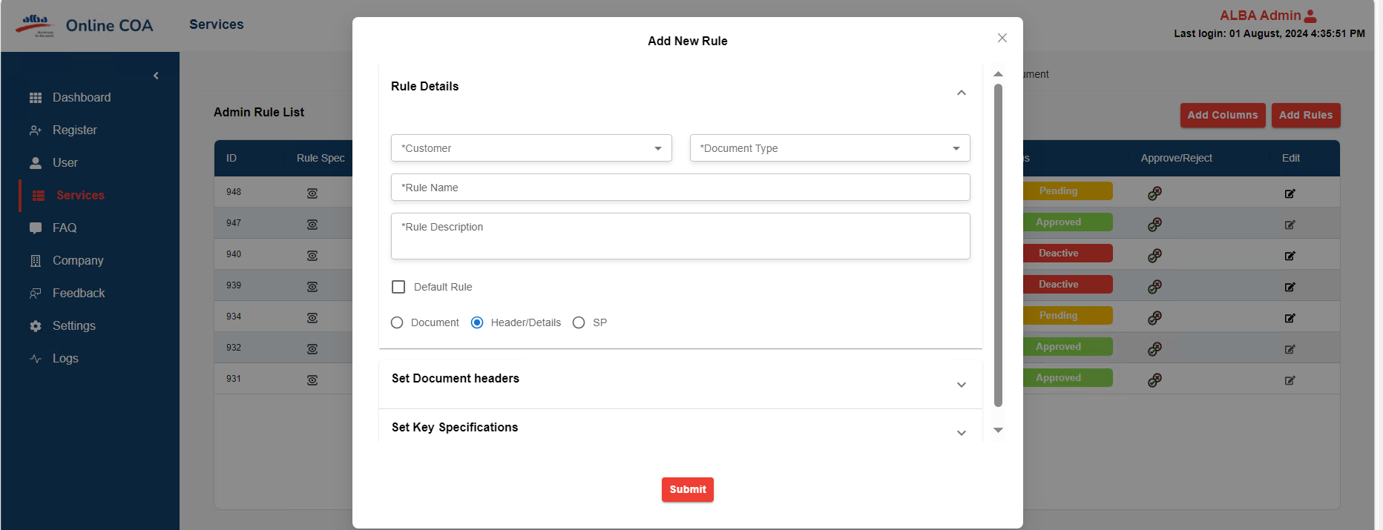

* Step:8

For new rule creation, admin needs to add customer name, document type and what name needs to apply for rule and description.

* Step:9

By default, it will be selected as Header Details. It will have set key document and set key specification. It has the Add and Delete all button and it provides by default data which can be edited or delete.

* Step:10

Click on add, it will provide input field as Keys, Parameter, Values and Sequence.

1. In keys it will have elements and keys, in parameter (Hide, Rename, Position, Truncate, Substring, Map, Concat, Assign, Blank, Trim and Tolnt).

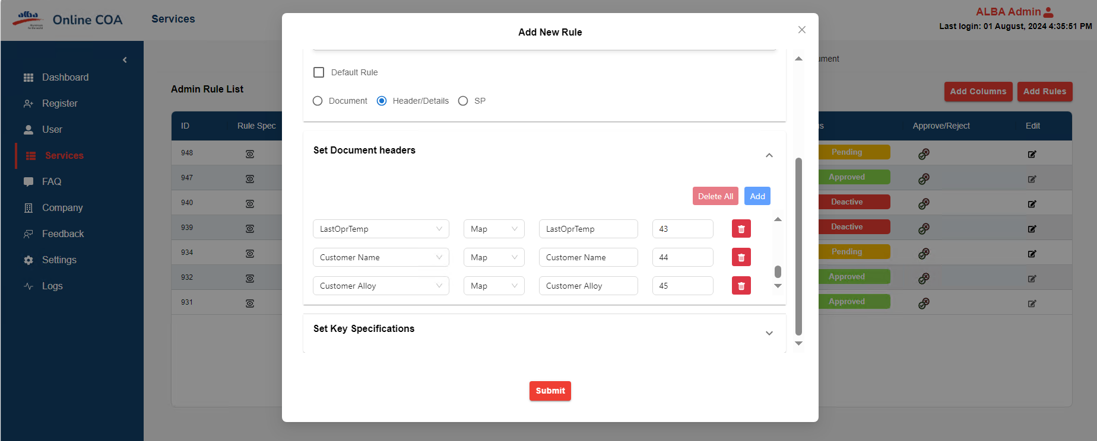

* Step :11

If any column needs to be for rule creation means admin can be able to add customized columns by clicking add column button, and if any of the columns doesn’t want can easily delete by clicking delete icon easily on screen.

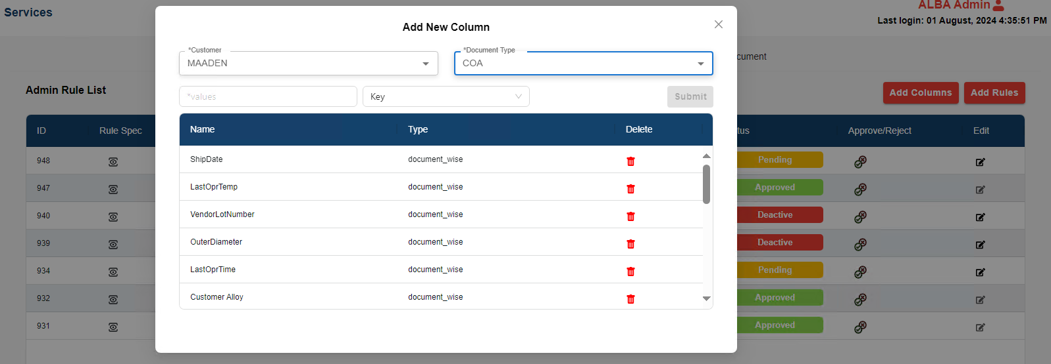

After adding columns, once rule Is created click submit button on add rule screen.

* Step:12

Once rule created, it added successfully on rules screen as pending state.

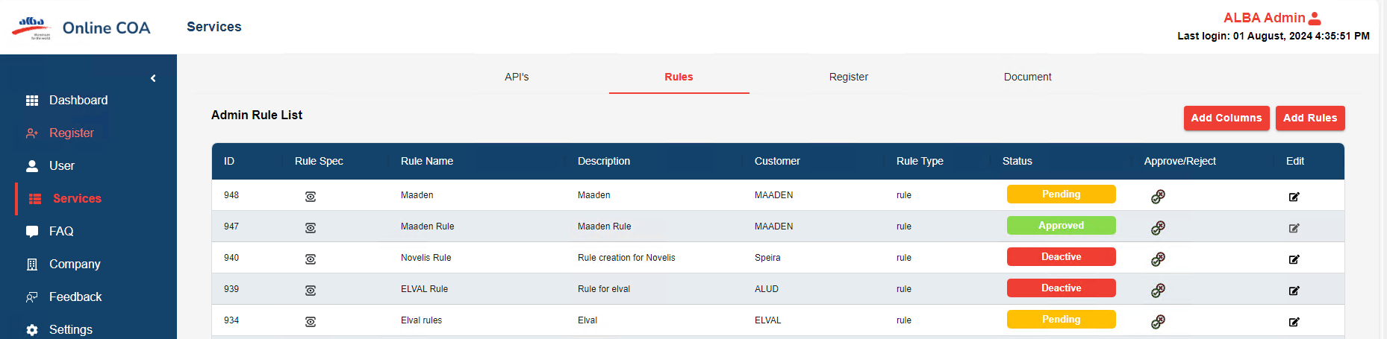

* Step:13:

Rule needs to be approved on add rule, initially it’s in pending state, by clicking Approve/Reject button for rule, it shows one pop-up like update rule status, add necessary comments and click submit.

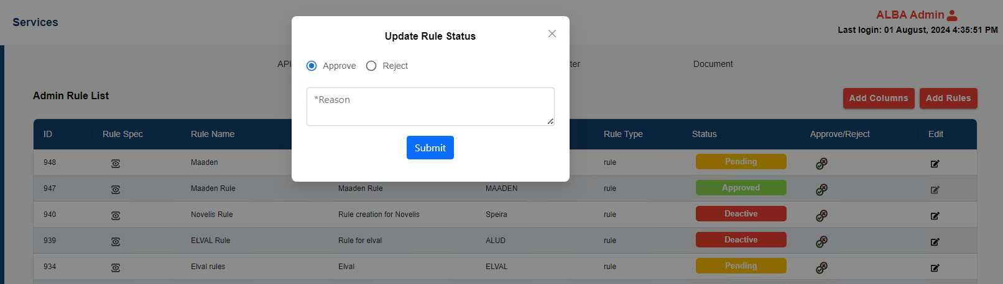

* Step:14

Click on document and admin can be able to check the company and rules for verification.

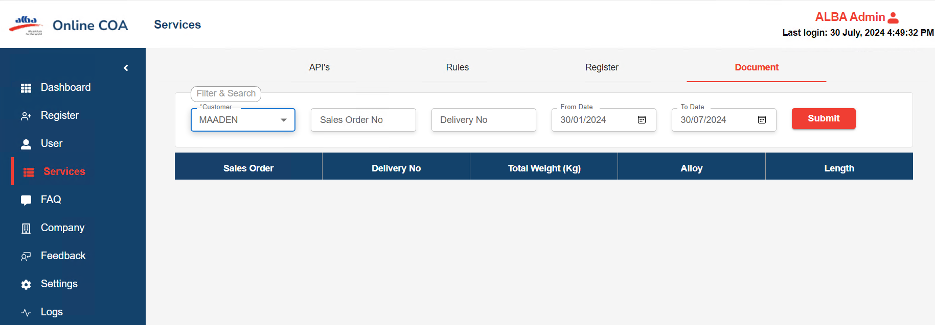

* After selecting customer name click submit,

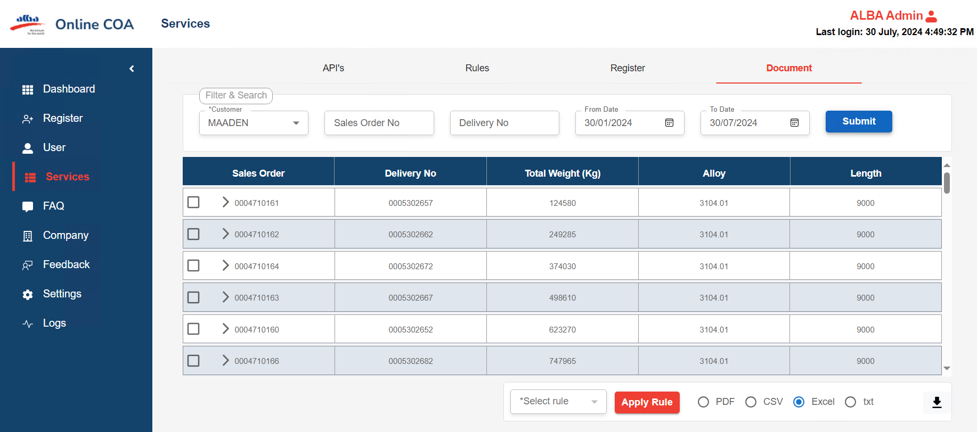

* From document screen admin can check the rules for company, click the sales order checkbox and click select rule dropdown, select rule and click **APPLY RULE** button.

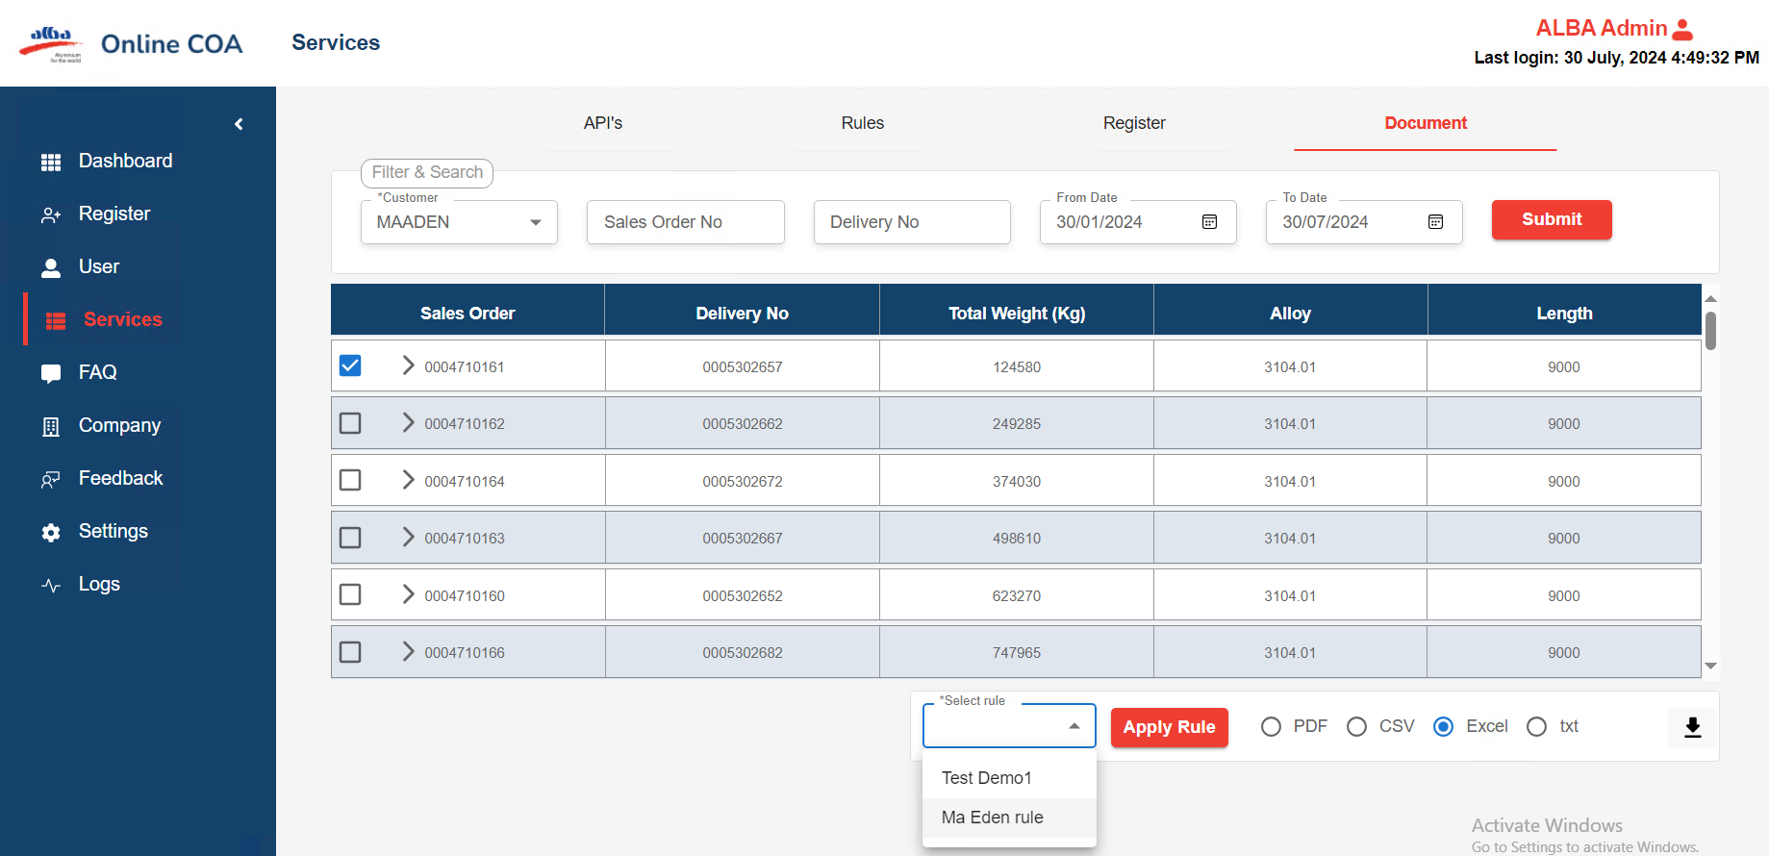

* Admin can be able to see raw data and converted data **as table view** and **JSON view.**
* Step:16

From request API screen, admin should approve the **API REQUEST RESPONSE** by clicking action button

* Click on Api, click on request it will give pop-up modal box it has app name, requestor name, email, details, select the rule, purpose of data consume then click on submit box.

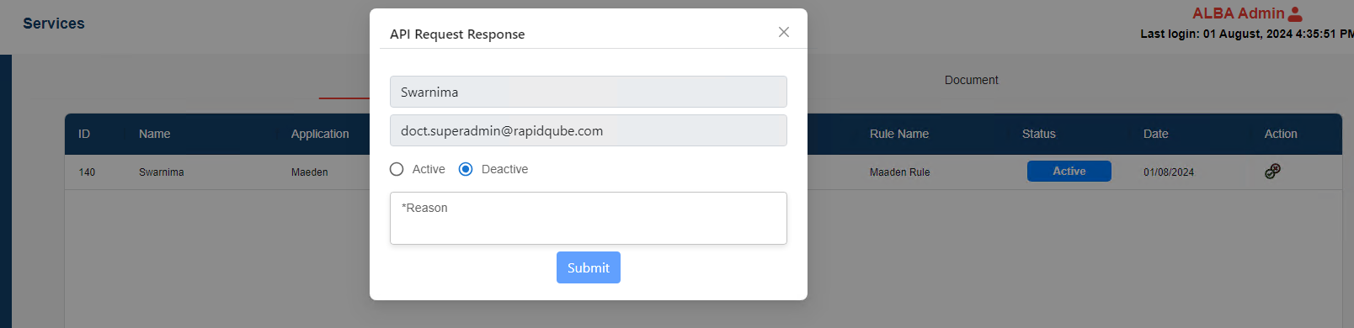

* After approval, customer can access rules Preview through API with JSON format

**Creating User as Admin**

* Login as Super admin.
* Create a new user from the below screen by filling in the required fields. If creating user for an existing company, choose “Existing Company” and select company from drop down. If it is a new company, then choose “New Company” and type in the Company name.

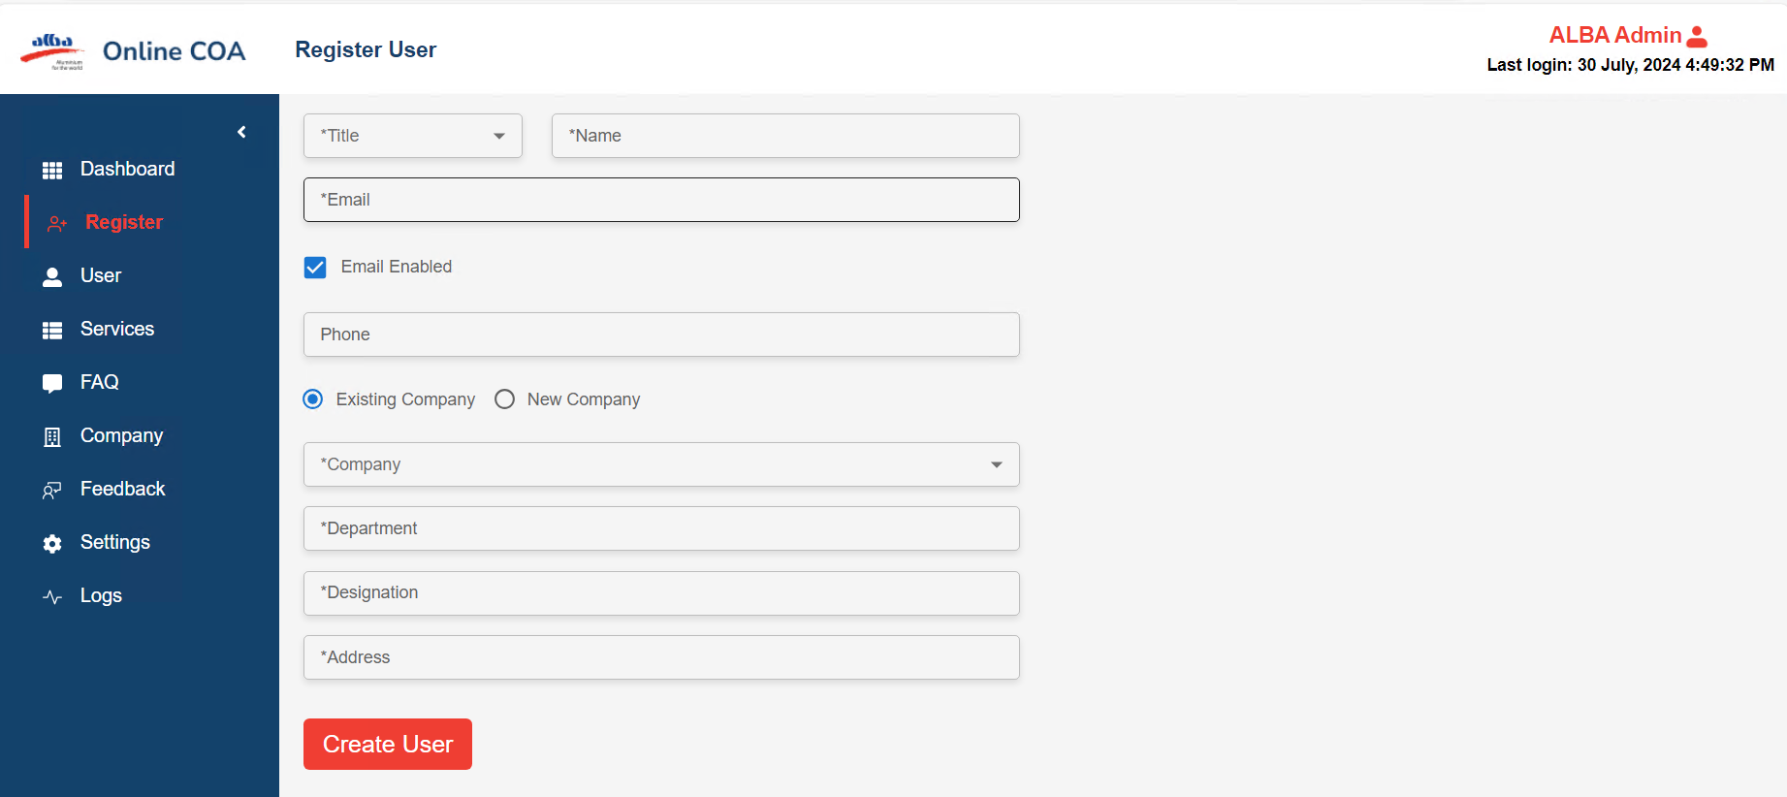

* After creating, the user details can be viewed in the user_details table. Make these two columns "is verified, invite_token_used" as true for that user in the user_details table.
* Then login with the temporary password. see column "temporary password" in user_details table. (Step 3 will not be necessary if the email of the user is verified in AWS SES and the user has received the invitation.)
* Hover on the email on the top-right, then click "My Profile", you will be navigated to the "/profile" page, as shown below. then click on "Change Password". Enter old password/temporary password, new password and confirm password to complete the change password flow.

